Name ____________________________ Date _________________ Period _______ **EOCT Review Ecology Questions**

1. **Organisms that use energy from the sun to make their own food are called**
   1. Carnivores c. Omnivores
   2. Consumers d. Producers

|  |  |  |  |  |  |  |  |  |  |  |  |  |  |  |  |  |  |  |  |  |  |  |  |  |
| --- | --- | --- | --- | --- | --- | --- | --- | --- | --- | --- | --- | --- | --- | --- | --- | --- | --- | --- | --- | --- | --- | --- | --- | --- |
| **Rainfall & Weeds**   |  |  |  |  | | --- | --- | --- | --- | | **Year** | **Rainfall (cm)** | **Sweet pea /m3** | **Chickory /m3** | | 1980 | 115.5 | 56 | 47 | | 1981 | 106.7 | 58 | 48 | | 1982 | 71.4 | 28 | 56 | | 1983 | 88 | 31 | 62 | | 1984 | 127.5 | 79 | 29 | |

**Answers available in ...**

**10**

**Take this time to do your  
best on this question.**

**spacer**

1. **The chart above shows the average population of two competing weeds over a square meter of ground in a Georgia field. The chart also gives the average rainfall for five successive years. If there was an extended drought in this area, which would be a reasonable prediction?**
   1. The population of both weeds would be reduced, but about equal
   2. Sweet peas will increase in number and gradually outcompete chickory
   3. Chickory will increase, because sweet peas appear to be sensitive to drought
   4. Both weeds will increase in population, because the drought will increase competition between them.
2. **In a typical food chain, about what percentage of energy is passed on to the next trophic level?**
3. 1% b. 10% c. 20% d. 40%
4. **In general, which trophic level has the LEAST energy available to it?**
   1. Producer c. Secondary consumer
   2. Primary consumer d. Tertiary consumer

***Viruses are not considered to be living things, but they depend upon living cells for energy, reproduction, and protection at the expense of the cells that they invade.***

1. **The type of relationship described above could best be classified as one of**
   1. Commensalism c. Parasitism
   2. Mutualism d. Resignation

***Plants → minnows → bass →bears***

1. **Consider the food chain. What would MOST LIKELY happen if the bass started to disappear because too many of them had been caught during fishing season?**
2. The number of bear will increase.
3. The plant population will increase.
4. The number of minnows would increase.
5. The number of minnows would decrease.

|  |
| --- |
| 3219 |

**Answers available in ...**

10

Take this time to do your  
best on this question.

spacer

1. **The graph shows the populations of wolves and mountain lions in five different counties in Montana. Wolves and mountain lions compete for the same kinds of food resources. In Clay county,** 
   1. mountain lions depend on wolves to survive.
   2. mountain lions probably outcompete wolves for food.
   3. mountain lions and wolves have a mutualistic relationship.
   4. mountain lions and wolves survive independent of each other.

**8. In the ecological pyramid, the amount of potential energy available for each trophic level**

1. Remains the same
2. Increases over time
3. Decreases from bottom to top
4. Increases from bottom to top

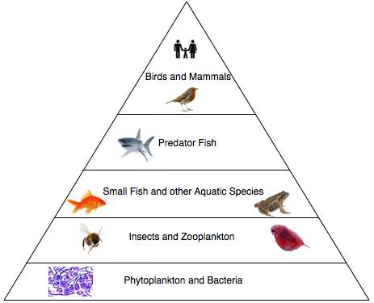

|  |  |
| --- | --- |
| **Body of Water** | **Salinity** |
| Butcher's Creek | 4 |
| Victoria Lake | 4 |
| Red Sea | 26 |
| Rio de la Plata Estuary | 15 |
| Atlantic Ocean | 26 |

1. **Rachel wanted to study a freshwater ecosystem for her science fair project. According to the table, she should pick the**
2. Red Sea c. Atlantic Ocean
3. Victoria Lake d. Rio de la Plata Estuary

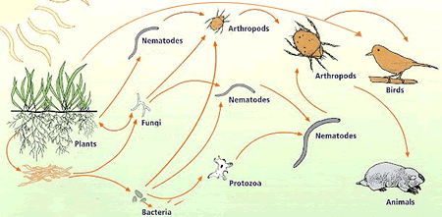

1. **In this food web, birds would be classified as**  A) carnivores. C) herbivores  
     B) decomposers. D) omnivores
2. **Human activities that increase carbon dioxide in the atmosphere are likely to cause which of the following environmental changes?**  A) decreased plant growth C) tsunamis

B) an ice age D) global warming

|  |
| --- |
| 1. **Clown fish have evolved resistance to the deadly stings of sea anemones. The sea anemone provides protection for the fish from predators, while the anemone is unaffected by the fish. The relationship between clown fish and sea anemones is a form of symbiosis called**   A) mutualism. C) competition   B) predation. D) commensalism |

1. **Humans make a negative contribution to the carbon cycle by**  A) driving cars. C) conserving energy  
     B) planting trees. D) using solar power
2. **Sustainable use is often defined as the use of natural resources at a rate that meets the needs of the present human population but which also allows future generations to use the resource to meet their needs. Which of these BEST illustrates the concept of sustainable use?**  A) Crops are rotated in a farmers field to maximize grain yields.  
     B) A fishing trawler use a large net to catch a school of small fish.  
     C) A logging company reseeds and replants in a forested area after cutting down trees for timber.  
     D) Coal is mined using underground tunnels to avoid the destruction of surface soils by strip mining.
3. **Biotic and abiotic factors are affected by and can influence geochemical cycles in ecosystems. Which of the following human activities does not affect geochemical cycles in aquatic ecosystems?**
   1. Overharvesting fisheries
   2. Dumping sewage into rivers
   3. Burning fossil fuels and wood
   4. Using excessive amounts of fertilizer
4. **Which of the following statements about the nitrogen cycle is true?**
   1. Nitrogen has a critical role in ecosystems because it is the primary building block of fats and lipids
   2. Most of the nitrogen in the nitrogen cycle is held in living plants
   3. Nitrogen reenters the atmosphere through animal and plant respiration
   4. Plants take in nitrogen through their roots
5. **Which of the following organisms would be most likely to occur on a small island that was formed by a volcanic eruption two years prior?**
   1. Climbing vines c. monkey
   2. Hardwood tree d. lichen
6. **Mycorrhizae are the union of plant roots with a certain species of fungus. The fungi attach themselves to plant roots and extract plant sugars from the roots for food. In turn, the fungi absorb nutrients from the soil and transfer them to the plants. What term best describes the relationship between these organisms?**
   1. Parasitism c. mutualism
   2. Commensalism d. phototropism
7. **Nitrogen gas makes up nearly 90% of the gases in the atmosphere. Nitrogen is also one of the most important elements for living things. However, higher plants are not able to utilize nitrogen for biological functions and instead must have nitrates. Which of the following enables the formation of nitrates by nitrification?**
   1. Pressure b. fungi c. viruses d. bacteria
8. **Over time, the burning of fossil fuels has increased the amount of greenhouse gases in our atmosphere. Many scientists are concerned that this buildup of greenhouse gases will cause an increase in Earth’s average temperature. This increase in temperature is predicted to result in many adverse environmental impacts. What is one of these impacts?**
   1. Less plant growth
   2. Less oxygen in the atmosphere
   3. More cancer in humans
   4. Flooding due to rising sea levels.